**QUESTION A**

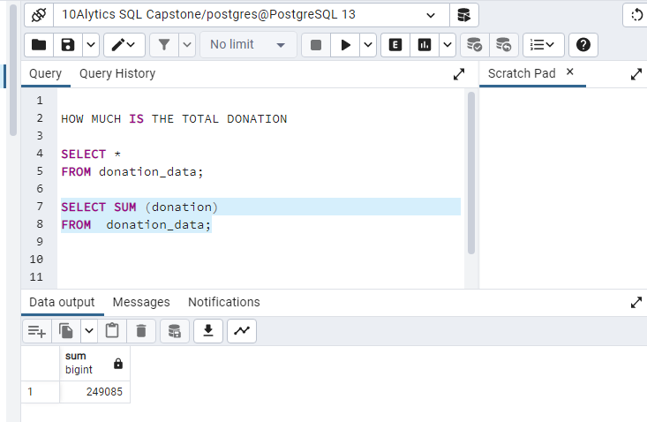

**QUESTION B**

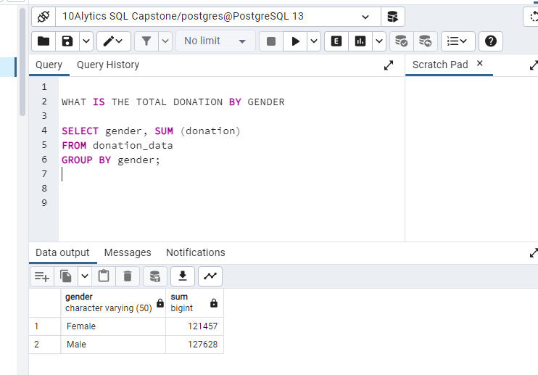

**QUESTION C**

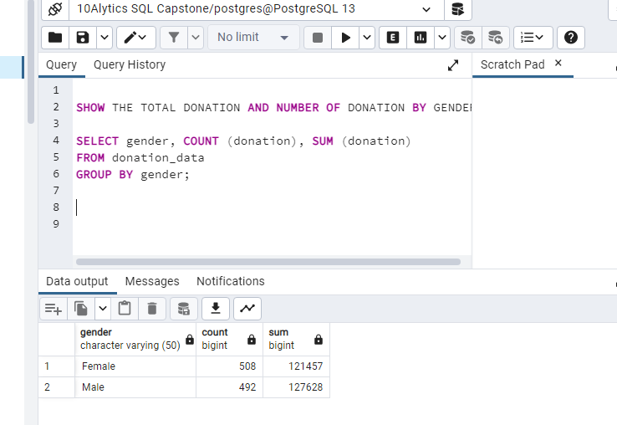

**QUESTION D**

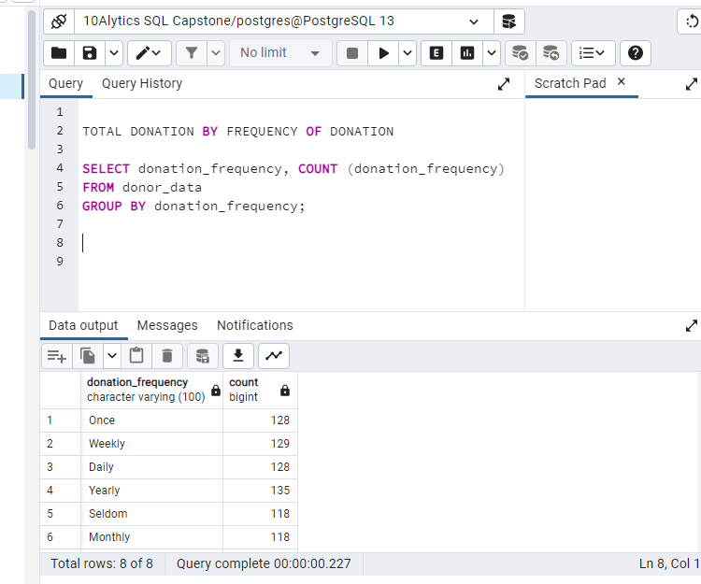

**QUESTION E**

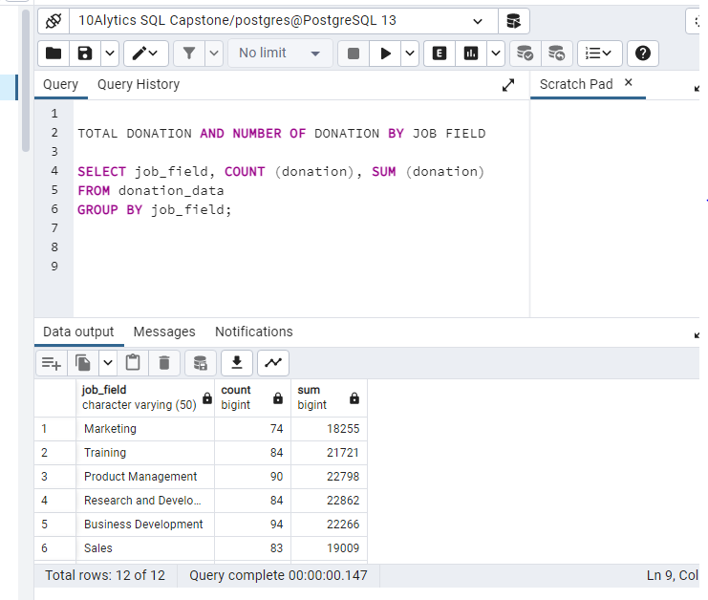

**QUESTION F**

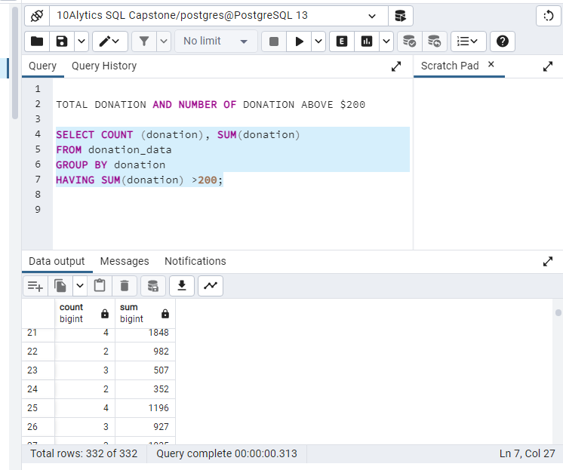

**QUESTION G**

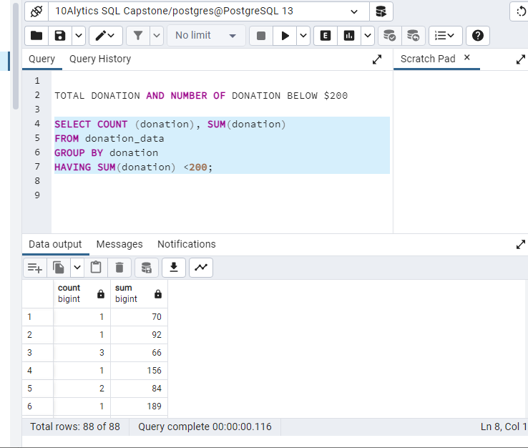

**QUESTION H**

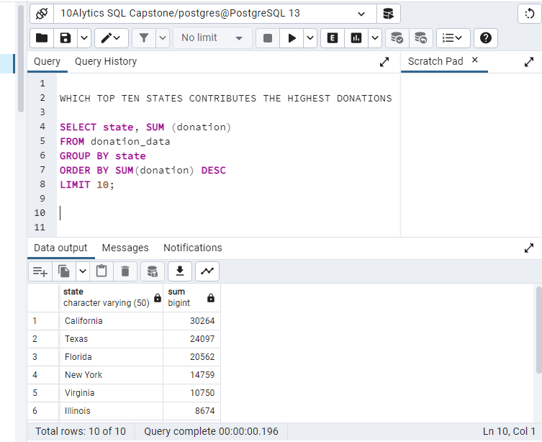

**QUESTION I**

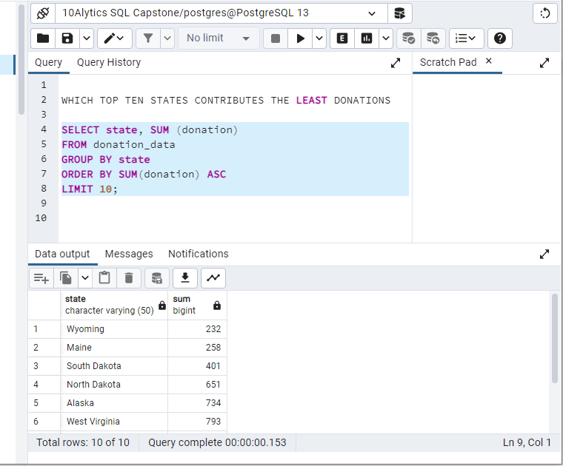

**QUESTION J**

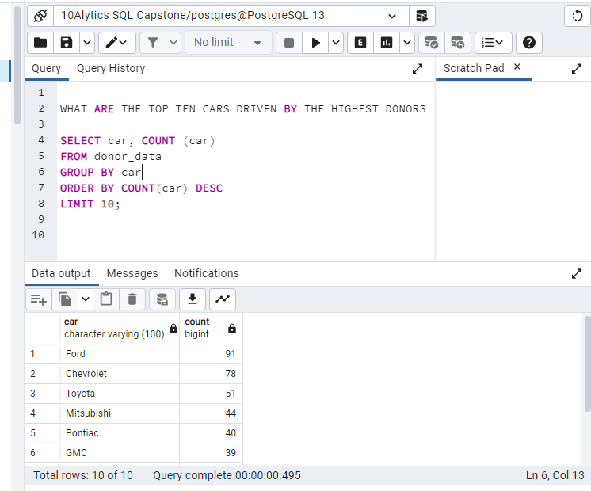

**SUMMARY**

What are your recommendations based on the insights

you generated from the solutions to:

• Increase the number of donors in your database

• Increase the donation frequency of your donors.

• Increase the value of donations in your database

Education for all fundraising is a very good initiative.

To increase the number of donors in the database, more awareness should be created on the goal and benefits of this project. They should also advertise and promote it beyond USA to other countries too.

To increase the donation frequency, the members may be encouraged to meet weekly, either physical or online to give their donation for the fundraising.

I believe when the number of donors increase and the frequency of donation also increases, the value of the donations will be increased.